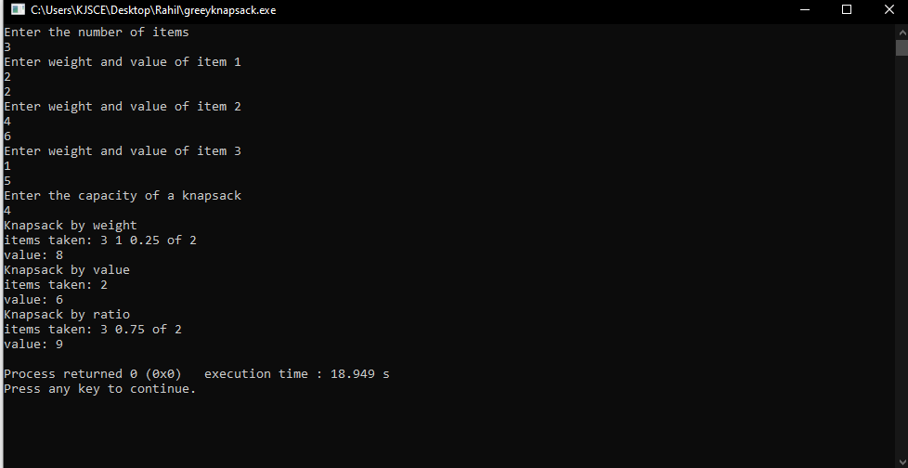

#include <bits/stdc++.h>

using namespace std;

void printArray(vector<vector<int>> &v)

{

cout << "The array is\n";

for(int i = 0; i < v.size(); i++)

{

cout << "Item: " << v[i][0] << " Weight: " << v[i][1] << " Value: " << v[i][2] << "\n";

}

}

bool by_weight(vector<int> a, vector<int> b)

{

return a[1] < b[1];

}

bool by_value(vector<int> a, vector<int> b)

{

return a[2] > b[2];

}

bool by_ratio(vector<int> a, vector<int> b)

{

return a[2]/a[1] > b[2]/b[1];

}

void greedy(vector<vector<int>> &v, int m)

{

vector<int> items;

int value = 0;

int a = 0;

for(int i = 0; i < v.size(); i++)

{

if(m >= v[i][1])

{

a++;

items.push_back(v[i][0]);

value += v[i][2];

m -= v[i][1];

}

else

{

break;

}

}

if(m == 0 || a == v.size())

{

cout << "items taken: ";

for(auto &i: items)cout << i << " ";

cout << "\n";

cout << "value: " << value << "\n";

return;

}

float fraction = (float)m/v[a][1];

if(fraction != 0)

{

value += fraction * v[a][2];

}

cout << "items taken: ";

for(auto &i: items)cout << i << " ";

cout << fraction << " of " << v[a][0];

cout << "\n";

cout << "value: " << value << "\n";

return;

}

int main()

{

int n;

cout << "Enter the number of items\n";

cin >> n;

vector<vector<int>> v(n, vector<int> (3));

for(int i = 0; i < n; i++)

{

cout << "Enter weight and value of item " << i + 1 << "\n";

v[i][0] = i + 1;

cin >> v[i][1];

cin >> v[i][2];

}

cout << "Enter the capacity of a knapsack\n";

int m; cin >> m;

cout << "Knapsack by weight\n";

sort(v.begin(), v.end(), by_weight);

greedy(v, m);

cout << "Knapsack by value\n";

sort(v.begin(), v.end(), by_value);

greedy(v, m);

cout << "Knapsack by ratio\n";

sort(v.begin(), v.end(), by_ratio);

greedy(v, m);

// printArray(v);

}